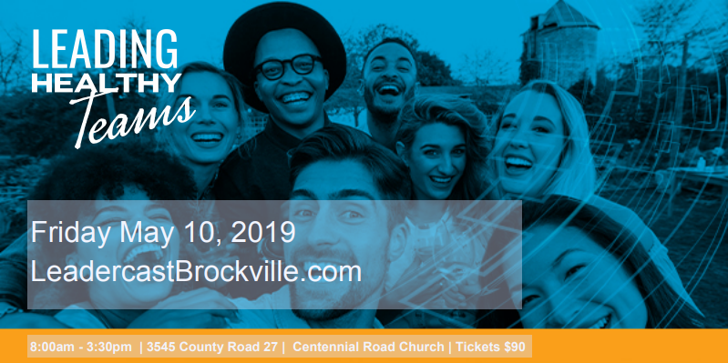

Join more than 100,000 leaders for the largest
one day leadership event in the world!

[Centennial Rd Church, Brockville, ON]
[Friday May 10, 2019]
[8:00am – 3:30pm]
Broadcast live from Atlanta to hundreds of locations around the world each year, Leadercast Live brings together some of the most recognized and respected global leaders to create a leadership experience unlike any other.
The Leadercast Live stage will feature leaders who will explain the power and importance of leading yourself ﬁrst so you can lead others well.
- What does it look like to lead yourself?
- How can you intentionally develop your own leadership skills and style?
- What qualities do you hope to embody as a leader?

Leadercast Live focuses on issues most relevant to today’s leader. People passionate about Sports & Fitness, Business & Entrepreneurial, Health & Wellness, Service providers, Not for Profit, Academia, and Community leaders are joining us. It is a pairing of inspiring messages and rich interaction with fellow leaders who are being intentional about raising their standard of leadership, through a creative, energetic and memorable experience.

Your $90 Ticket includes snacks, beverages, healthy lunch, parking, and your journal. Why pay over $250 to attend in bigger city and pay for parking too?
Bring your team, your favorite client, or a young person who would love the chance to be with you for the day.

Our 2019 Speaker line up!
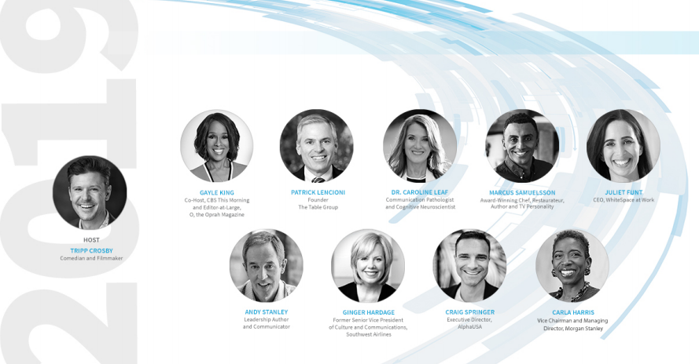

Patrick Lencioni
He is the expert on organizational health and the author of a dozen books. His tools they need to improve teamwork.

Marcus Samuelsson
The kitchen can be a fiery place to work, but Marcus has proven he can create a successful culinary experience. Hear the award-winning chef speak about healthy teams. Let’s also hope that he will share some insight on his new restaurant opening in Montreal.

Gayle King
She has helped expand a media empire when she became editor-in-chief of O, The Oprah Winfrey Magazine

Andy Stanley
A Leadercast fan favorite and a best-selling author and leadership communicator, Andy uses real-world anecdotes to relay insightful messages that are always memorable.

Ginger Hardage
Build an organizational culture that every consumer feels with Southwest Airlines Vice President of culture and communications.

Align your business and brand with a complimentary one such as Leadercast and take advantage of the like-minded business owners, community leaders, and front-line team members you’ll meet on May 10th.

Our sponsors play a key role in allowing us to deliver this world-class event and still keep our ticket price well below that of our neighbors in the big cities.

Our levels of sponsorships are detailed below. We appreciate your continued support of this important event and we extend tremendous gratitude from all of us at Leadercast Brockville Team!

Sponsorships | Benefits
Leadership $1000 | - 5 Complimentary tickets  - Join us on stage to be introduced and help us present our Community Leadership Award  - Prime location for your table in our vendor alley  - Name and Logo prominently displayed throughout the day on our big screens  - Sponsorship promoted on Social Media
Champion $500  (2 available) | - 3 Complimentary tickets  - Opportunity to provide a door prize  - Complimentary display table in our vendor alley  - Name and Logo displayed throughout the day on our big screens  - Sponsorship promoted on Social Media
Influencer $300 | - 1 Complimentary ticket  - Complimentary display table in our vendor alley  - Name and Logo displayed throughout the day on our big screens

Tickets on sale now!

On May 10^{th,} we invite you to join us to hear some of the most recognized leaders in the world as you hang out and learn with many amazing local leaders to said YES.

Shelli Warren, Co-Chair
Get Your Ticket

