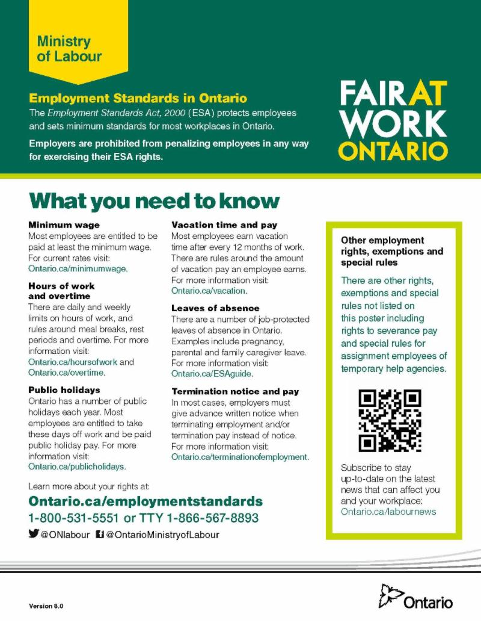
Business Owners with employees. New version of the ESA poster which must be posted plus a copy must be given to your employees.

Click on the link to print your new version:
https://files.ontario.ca/employment-standards-in-ontario.pdf

