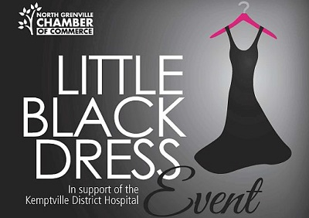
Friday October 20th 2017 – 6pm to 12am
Social Hour 6-7pm

Equinelle Golf Club
140 Equinelle Dr. Kemptville ON, K0G 1J0

SPONSORSHIP LEVELS:
(Please note: Company name or Logo and placement will be in accordance w/sponsorship level)

Hosted by: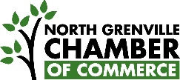
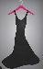 Platinum Pink Dress – Title Sponsor - $5000

- Exclusive speaking opportunity at event
- 8 tickets (1 table) at the Little Black Dress Event
- 8 drink tickets for the Little Black Dress Event
- Appropriately sized company name &/or logo in print & online event invitations, press release, online event marketing, social media outreach (deadlines will apply), newspaper & newsletter advertising, radio spots
- Company name &/or logo on sponsor recognition boards at event
- Company name &/or logo on the North Grenville Chamber of Commerce website, twitter and Facebook list of sponsors
- Foremost acknowledgement at event
- Invitation to cheque presentation and photo opportunity, newspaper, radio and monthly newsletter
- First right of refusal for the 3rd Annual Little Black Dress Event 2018

Platinum Black Dress – Platinum Sponsor - $2500

- 8 tickets (1 table) at the Little Black Dress Event
- Appropriately sized company name &/or logo in print & online event invitations, press release, online event marketing, social media outreach (deadlines will apply), newspaper & newsletter advertising, radio spots
- Company name &/or logo on sponsor recognition boards at event
- Company name &/or logo on the North Grenville Chamber of Commerce website, twitter and Facebook list of sponsors
- Invitation to cheque presentation and photo opportunity, newspaper, radio and monthly newsletter
- First right of refusal for the 3rd Annual Little Black Dress Event 2018

Hosted by:

Gold Dress – Gold (Room) Sponsor 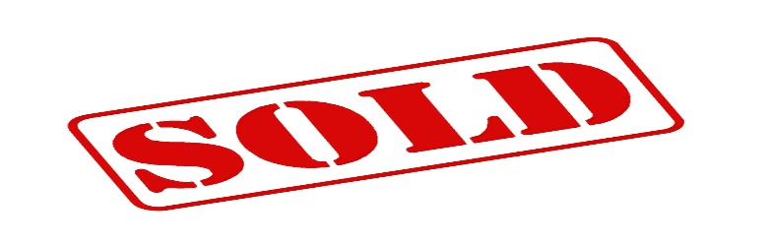

- 8 tickets (1 table) at the Little Black Dress Event
- Appropriately sized company name &/or logo in print & online event invitations, press release, online event marketing, social media outreach (deadlines will apply), newspaper & newsletter advertising, radio spots
- Company name &/or logo on sponsor recognition boards at event
- Company name &/or logo on the North Grenville Chamber of Commerce website, twitter and Facebook list of sponsors
- Invitation to cheque presentation and photo opportunity, newspaper, radio and monthly newsletter
- First right of refusal for the 3rd Annual Little Black Dress Event 2018

Silver Dress – Silver Sponsor - $1000
- 8 tickets (1 table) at the Little Black Dress Event
- Appropriately sized company name &/or logo in print & online event invitations, press release, online event marketing, social media outreach (deadlines will apply), newspaper & newsletter advertising, radio spots
- Company name &/or logo on sponsor recognition boards at event
- Formal acknowledgement at event
- Invitation to cheque presentation and photo opportunity, newspaper, radio and monthly newsletter
- First right of refusal for the 3rd Annual Little Black Dress Event 2018

Hosted by:

